**Trello: Codelitt chaos, organized**

*What Trello Is*

Trello is a collaboration tool that allows teams to organize and track work easily from a sleek and flexible interface. It can be used on any device. Although the use cases and possibilities are virtually endless, this summary will focus on how Trello is used at Codelitt, Inc.

*How Trello Works*

To get started, go to trello.com and sign up. Send your brand new user name to the Project Admin or Manager (PM) and he/she can start adding you to projects. Unless you are the PM, then start creating your own.

Trello is divided into 4 major hierarchies: teams (previously organizations) > boards > lists > cards

These roughly translate into: project > team > phase > task

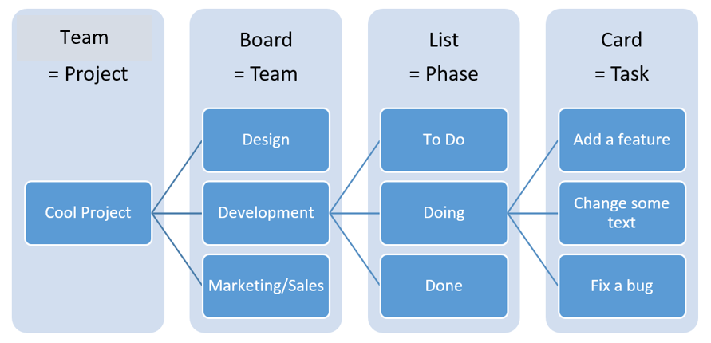

This hierarchy allows each team on each project to manage and track the progress of each task and, thus, the project as a whole.

Here is an actual screen shot of a Trello board, showing how the lists and cards are set up.

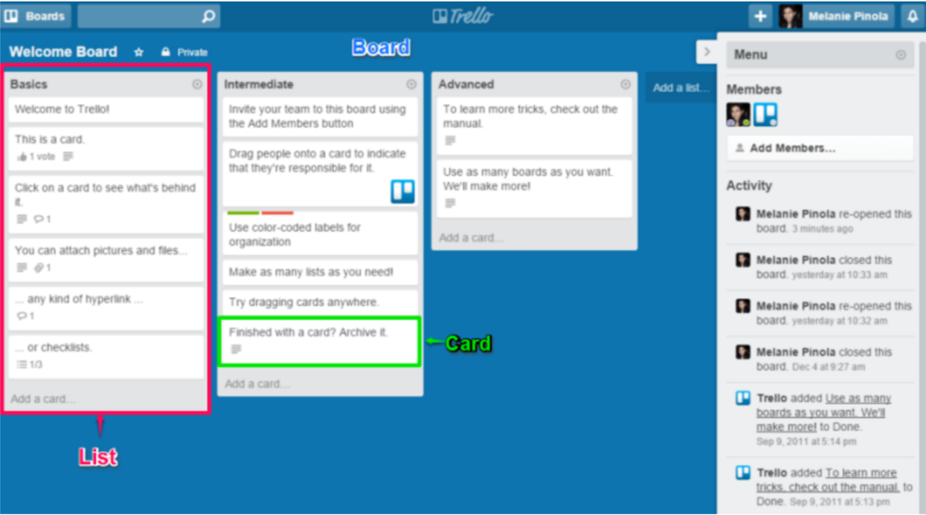

Project (‘Team’ on Trello)

Projects can be created by clicking the + menu at the top right of the dashboard. Then, select “Create personal team.”

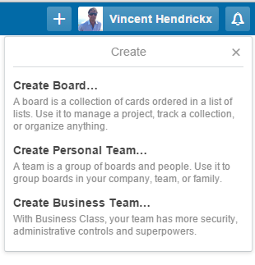

Once you’ve entered a name, a description and created the project, you will get redirected to the project page. From here you can start adding boards but also manage the members of the projects (those that will be involved and working on it), edit the project profile, change the privacy settings or delete it. This page can later be accessed from any of the boards of this project.

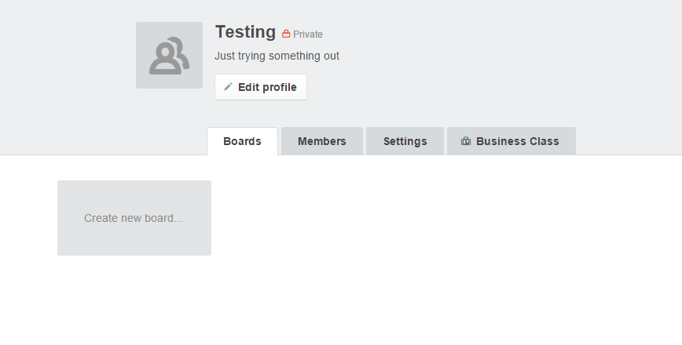

The different projects you are a member of can be viewed on the dashboard of the landing page or on the left “Boards” navigation menu.

Boards

Projects are split up into different boards, which usually represent the different teams or departments that are involved. Having several boards reduces cluttering and brings focus to the different work flows of any given project, allowing them to be visualized independently. For example, if we are building and designing a mobile app, we may have the following boards: Planning, Design, iOS Development, Android Development, Visible to Client, etc.

Having different boards also allows you to view only what you need to. For example, if a client wants to follow the progress of each feature, you may want to create a board that is only visible to the client. Here you can show the progress of a project but at the same time shield the team members from any direct requests or keep all internal discussions and matters on the other boards.

Boards have a few functions other than creating lists and cards (will get to that next) that are worth mentioning.

* From the side menu, you can **view and add members** to each specific board
* From the side menu, you can **filter** what is displayed on the board. Filters include by label, by member, by due date.
* From the side menu, you have access to all the **past activity** of that board. This allows for an easy way to get caught up on a board you have not viewed in a while.
* From the header, you can **search** text in cards from all the projects. Refine your search with operators like @member, #label, is:archived, and has:attachements.
* From the header, you can access your **notifications** so you can navigate directly to card that have changed where you are added or where you were mentioned.

Lists

As seen in an earlier image, lists are organized horizontally on the board and should follow a natural progression from left to right. Therefore, any list to the right of another should be upstream in the work flow. Simple boards may have list that look something like: To Do > Doing > Done

The lists on our more complex development boards may look something like this:  
Design > Backlog > Up Next > Sprint > Issues > Working On > Pull Request > QA > Approved > Live

where;

Design = includes cards with design files and assets that the developers may use for reference. This list can be populated by the design team or the project manager (come from Design boards).

Backlog = includes cards with tasks/ideas to be implemented in the future and may need a more complete spec and/or design. This list can be populated by anyone.

Up Next = includes cards with tasks that have been speced and designed and are planned to be developed in the foreseeable future. This list is populated by the project manager or the lead dev (may be new or come from Backlog).

Sprint = includes cards with tasks to be completed by the next release. This list is populated by the project manager (come from Up Next).

Issues = includes cards with bugs or tasks that did not pass QA and are to be attended to ASAP. This list is populated by the project manager or the lead dev (come from QA or dog-fooding).

Working On = includes cards with tasks that are currently being worked on. This list is populated by the devs working on the tasks (come from Sprint or Issues).

Pull Request = includes cards with tasks that have been finished and have a pull request on Git. This list is populated by the devs working on the tasks (come from Working On).

QA = includes cards with tasks that have been merged and deployed to the QA/testing instance of the project. This is populated by the dev in charge of deploying (come from Pull Request).

Approved = includes cards with tasks whose completion, desired function and look have been confirmed in the QA process and, thus, approved. This list is populated by the QAer (come from QA).

Live = includes cards with tasks that have been deployed to the live production instance of the project. This list is populated by the dev in charge of deploying or the project manager and may be archived from time to time (come from approved).

Other functions worth mentioning:

* Each list has a title that can be edited. The title may include a brief description of what to expect from the cards that populate it. For example, “need to be speced.”
* Each list can be dragged and dropped to easily change the order of the work flow.

Cards

Cards can be used for any number of things but are usually a specific task or feature that is desired to be included in the project. A card can be created by clicking “Add a card” at the bottom of any list. Cards may also be moved from list to list with a simple drag and drop. Cards tend to be created downstream, or on the left side of the trello board, and move their way up stream as they pass through the work flow.

You want to avoid cards being tasks that are too board and cover too much work. “Build front end of app” would be a bad card and cover too much ground. On the other hand, there is no need to be too specific either. “Change headline font,” “change headline color” and “change headline copy” could best be group together in one card, “changes to headline.”

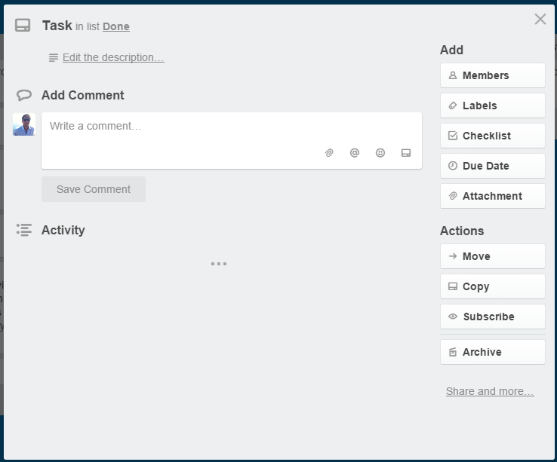

The cards include several functions but we shall cover those that are most useful to us:

**Must Have!**

* Title that allows you to easily identify and search that particular card.
* Description which explains the desired outcome in as much detail as possible.
* Checklist of acceptance criteria. If this check list gets too long, it is usually wise to create additional cards. The card can also contain more than one checklist. For example, if the card is not approved in QA, a new checklist will be created called “QA” describing the remaining issues.
* The checklist items need to be checked off as completed.
* Member needs to be added once the cards has been moved to Working On.
* Comment to discuss any doubts or questions regarding the task at hand.
* Tag people in the comments with @ if there are any questions or comments directed to that particular person.
* Due date when the card is moved to Current Sprint.

**Great to Have**

* Color labels that describe what type of task it is. This allows for an easy to recognize visualization of what is being worked on when looking at the entire board. They can also be used to show that a card is blocked because of a dependency. Examples of labels include front-end, back-end, bug, mobile, blocked, and so forth. These labels will be pre-determined or added by the project manager or lead dev.
* Attachments can be added via the button or copied into the description. Most common attachments are design assets that apply to the feature being worked on and screenshots or videos of bugs/issues.
* Estimation of how long the task will take using <http://scrumfortrello.com/>
* Time spent on the card using <http://scrumfortrello.com/>

**Other Functions**

* Cards can be moved or copied to other lists or boards as desired.
* Cards can be shared by copying their specific url in the “Share and more…” menu.
* Cards can be archived if no longer relevant but this should be left to the project manager.

Please visit the following links for more info:

<https://trello.com/guide>

<https://trello.com/tour>

<https://trello.com/shortcuts>